3. NEWTON’S RAPHSON METHOD
Q. WRITE A PROGRAM IN PYTHON TO DEMONSTRATE NEWTON RAPHSON METHOD
AIM: TO WRITE A PROGRAM IN PYTHON TO DEMONSTRATE NEWTON RAPHSON METHOD
PROGRAM:
Import math

# Safely evaluate the user-defined function
def safe_eval(expr, x):
try:
return eval(expr.strip(), {"x": x, "math": math, "_builtins_": None})
except (NameError, TypeError, ZeroDivisionError, SyntaxError) as e:
print(f"Error evaluating function: {e}")
return None

# Safely evaluate the derivative of the function
def df(x, deriv_str):
try:
return eval(deriv_str.strip(), {"x": x, "math": math, "_builtins_": None})
except Exception as e:
print(f"Error evaluating derivative: {e}")
return None

def Newton_Raphson_Method(func_str, deriv_str, x0, tol, max_iter=100):
ai = x0

print("\nIter.\t ai\t\t f(ai)\t\t df(ai)\t\t ai+1")
for i in range(1, max_iter + 1):
fai = safe_eval(func_str, ai)
dfai = df(ai, deriv_str)

if dfai == 0:
print("Derivative is zero. Method fails.")
return None

# Newton-Raphson Formula
ai_p1 = ai - fai / dfai

print(f"{i:<6}\t {ai:.4f}\t {fai:.4f}\t {dfai:.4f}\t {ai_p1:.4f}")

if abs(ai_p1 - ai) < tol:
print(f"\nApproximate root = {ai_p1:.3f} (correct to 3 decimal places)")
return ai_p1

ai = ai_p1

print(f"\nMaximum iterations reached without convergence.")
return ai_p1

import math
print("## Newton-Raphson Method ##")

# Example 1: "x*x - 4*x - 4"
# Example 2: "m.cos(x) - x"
# Example 3: "x**3 - x - 1"
# Example of derivative: "3*x*x - 1" for f(x)=x**3 - x - 1

func_str = input("Enter the function f(x): ")
deriv_str = input("Enter the derivative df(x): ")
x0 = float(input("Enter the initial guess x0: "))
tol = float(input("Enter the tolerance for X decimal place accuracy: "))

newton_raphson(func_str, deriv_str, x0, tol)

OUTPUT:
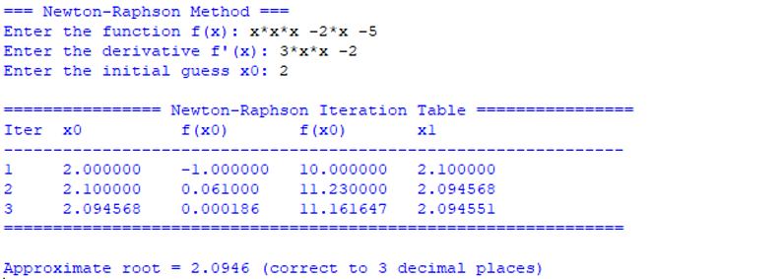
CONCLUSION:
The above program has been executed successfully.

